**HW4 Part 1**

Q1) Knowledge of operations management is essential for which business fields?

1. Accounting
2. Law
3. Marketing
4. All of the above

Answer: d

Knowledge is necessary for most if not all business operations, Week 12 Slide 15.

Q2) Which of the following is usually the most expensive cost of quality?

* 1. Appraisal costs
  2. Prevention costs
  3. Internal failure costs
  4. External failure costs

Answer: d

External failure costs are more expensive because there is a cost for warranty and returns of the failed product, but also litigation if the company is sued, and the company’s reputation is affected. Module 13 Lesson 2

Q3) What can the Statistical Process Control chart tell us?

1. If product quality is normally distributed
2. If a process is showing signs of any assignable cause of variation
3. If a process is capable of meeting a necessary requirement

Answer: b  
Data plotting and monitoring is to watch for assignable / special causes of variation (the causes we can do something about). Week 13 Lesson 4

Instructions for Q4-Q7:

**Use the following for Questions 4-7. Assume 3 sigma limits**:

Alicia is an engineer at Robotics Inc. A critical dimension is the length of a wire. Alicia has taken 5 wires per day and measured them for the past 3 days. Her recorded measurements in millimeters (mm) are given in the table below:

|  |  |  |  |
| --- | --- | --- | --- |
| Sample | **Observation 1** | **Observation 2** | **Observation 3** |
| 1 | 6.43 | 5.86 | 7.42 |
| 2 | 5.33 | 4.58 | 6.44 |
| 3 | 7.14 | 5.22 | 4.08 |
| 4 | 6.52 | 6.71 | 7.19 |
| 5 | 6.41 | 6.15 | 6.77 |

Q4) Using Alicia’s data, what is the value of R-bar rounded to 3 decimal places?

* 1. 1.312
  2. 1.554
  3. 1.788
  4. 2.014

Answer: b.

R_bar is the average of the spread of each sample.

|  |  |  |  |  |  |  |
| --- | --- | --- | --- | --- | --- | --- |
| Sample | Obs 1 | Obs 2 | Obs 3 | Max | Min | Max-Min |
| 1 | 6.43 | 5.86 | 7.42 | 7.42 | 5.86 | 1.56 |
| 2 | 5.33 | 4.58 | 6.44 | 6.44 | 4.58 | 1.86 |
| 3 | 7.14 | 5.22 | 4.08 | 7.14 | 4.08 | 3.06 |
| 4 | 6.52 | 6.71 | 7.19 | 7.19 | 6.52 | 0.67 |
| 5 | 6.41 | 6.15 | 6.77 | 6.77 | 6.15 | 0.62 |
|  |  |  |  |  | Average Max - Min | 1.554 |

Q5) What are the upper and lower control limits for the R chart (Given D4 = 2.5746, D3 = 0.000), rounded to 2 decimal places?

* 1. LCLr = 0.22 , UCLr = 3.84
  2. LCLr = 0.22, UCLr = 4.00
  3. LCLr = 0, UCLr = 3.84
  4. LCLr = 0, UCLr = 4.00

Answer: d

UCLr = R_bar * D4 -> 1.554*2.5746 = 4.00

LCR = R_bar*D3 -> 1.554*0.000 = 0

Q6) What are the upper and lower control limits for the x-bar chart (Given A2 = 1.0233), rounded to 2 decimal places?

* 1. LCLx = 4.41, UCLx = 7.90
  2. LCLx = 4.45, UCLx = 7.83
  3. LCLx = 4.56, UCLx = 7.74
  4. LCLx = 4.58, UCLx = 7.42

Answer: c

X_bar is the average of averaged observations of each sample:

|  |  |  |  |  |
| --- | --- | --- | --- | --- |
| Sample | Obs 1 | Obs 2 | Obs 3 | Average |
| 1 | 6.43 | 5.86 | 7.42 | 6.57 |
| 2 | 5.33 | 4.58 | 6.44 | 5.45 |
| 3 | 7.14 | 5.22 | 4.08 | 5.48 |
| 4 | 6.52 | 6.71 | 7.19 | 6.81 |
| 5 | 6.41 | 6.15 | 6.77 | 6.44 |
|  |  |  | x_bar | 6.15 |

UCLx = X_bar + A2*R_bar = 6.15 + 1.0233*1.554 = 7.74

LCLx = X_bar + A2*R_bar = 6.15 - 1.0233*1.554 = 4.56

Q7) Plot the R chart for Alicia’s data. Which statement is true about the R chart?

* 1. There are 2 R data points above the UCLr line.
  2. There is 1 R data point on the LCLr line.
  3. The R-bar line is below the LCLr line.
  4. All R data points fit between the LCLr and UCLr lines.

Answer: d

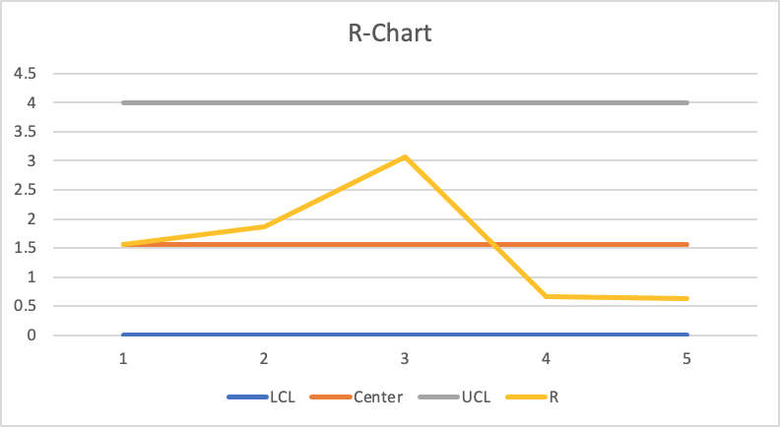

**Instructions for Questions 8-9:** Quickest Trippy is a local gas station. They want to predict demand for gasoline and have the following historical data:

|  |  |  |
| --- | --- | --- |
| Month | Demand (in **thousands** of gallons) | Forecast |
| 1 | 12 |  |
| 2 | 17 |  |
| 3 | 20 |  |
| 4 | 19 |  |
| 5 | 24 |  |

Q8) Using α = 0.2 and δ = 0.4 as well as F1=11,000 and T1=2,000 what would be the Trend Component predicted for month 2 (T2) (in thousands)?

1. 1.92
2. 12.8
3. 2.10
4. 15.18

Answer: a

FIT at month 1 = F1+T1 = 13 (*Note the data in the table is in thousands)

F2= FIT1 * (1-0.2) + A1*0.2 = 13*0.8+12*0.2 = 12.8

T2= T1 + 0.4*(F2 – FIT1) = 2 + 0.4 * (12.8-13) =1.92

 Q9) Using α = 0.2 and δ = 0.4 as well as F1=11,000 and T1=2,000 what would be the Forecast Including Trend for month 2 (FIT2) (in thousands)?

1. 15.18
2. 12.8
3. 14.72
4. 17.28

Answer: c

FIT2 = F2 + T2 = 1.92+ 12.8 = 14.72

Q10) Which of the following is not true about Exponential Smoothing’s alpha?

1. The closer alpha is to one, the more data points it uses in the forecast.
2. t denotes importance of the past error.
3. It determines how much the error alters the next prediction.
4. A large alpha means the forecast is reactive.

Answer: a

The closer alpha is to one, the less data points it uses in the forecast.